AN ICONOLOGICAL ANALYSIS OF ONE OF THE FORMS OF THE MINEIRO JUSTICE SYSTEM: THE HISTORICAL EXPERIENCE OF BOM JESUS DE MATOSINHOS IN CONGONHAS DO CAMPO (MINAS GERAIS, BRAZIL)

Paulo César Pinto de Oliveira
Abstract
This article develops an iconological analysis of the architecture and statuary of the Santuário de Bom Jesus de Matosinhos in Congonhas do Campo, Minas Gerais, Brazil. It studies the distinct representations of justice in the history of colonial Mineiro law, through works of religious art, promoting the encounter between the history of law and religion, more particularly eighteenth century Catholicism. The study focuses on the chapels representing the steps of the Passion of Christ, on the one hand, and on the prophets of the basilica's churchyard, on the other, commenting on the religious baroque and rococo art from the latter eighteenth and early nineteenth centuries. The central hypothesis is that Aleijadinho's statuary may have anticipated a recurrent iconological element in the images of Tiradentes in the Brazilian Republic. Essentially, it likens his figure to Christ, characterizing a dimension that transcends justice and revolves around martyrdom that brings salvation.

Keywords
Legal History. Law and Art; Iconology. Colonial Justice. Law and Religion. Catholic Baroque Art.

Summary
1. Introduction. 2. Religious art as expression of justice. 3. Justice in Aleijadinho’s works in Congonhas do Campo (Minas Gerais). 4. Conclusion: The prophets and the secret denunciation of Portuguese injustice. 5. References.

1. INTRODUCTION

The purpose of this work is to develop an iconological analysis of the architecture of the sanctuary Santuário de Bom Jesus de Matosinhos in Congonhas do Campo, Minas Gerais, Brazil. The analysis of the sanctuary’s architecture illustrates the encounter between the history of law and religion, and more particularly eighteenth century Catholicism. It focuses on the chapels representing the steps of the Passion of Christ, on the one hand, and on the prophets of the basilica's churchyard, on the other, uniting the history of law with religious baroque and rococo art from the latter eighteenth and early nineteenth centuries. The central hypothesis is that Aleijadinho’s artworks may have anticipated a recurrent iconological element in the images of Tiradentes in the Brazilian Republic. Essentially, it likens his figure to Christ, characterizing a dimension that transcends justice and revolves around martyrdom that brings salvation.
Erwin Panofsky states that art is every object produced by humans that requires esthetic experience. Three components structure a work of art as an esthetic object: the materialized form, the idea and the intentional content, which provides the most significant element in the esthetic investigation, depending on its universality and historical-rational range. According to Panofsky, the content of esthetic experiences is never private because each act, experience, and type has universal content.
Panofsky also affirms that the analyses of works of art are developed in stages, progressively understanding significations. These stages or layers are by-products of iconography and iconology, investigative fields of art history. Iconography dedicates to studying the theme, the message, or the meaning of the artwork using its form. It describes and classifies images. The first investigative step in iconography is the presentation of the artistic motives – the pre-iconography –,identifying lines, colors, artistic materials, and how they impact the characterization of natural objects and human ideas. This phase also identifies the atmosphere in the artwork’s expressions. The second stage of iconographic investigation involves the secondary motives, identifying specific subjects, concepts in the imagery, stories, and allegories in the artwork. The art’s date, origin, and authenticity are determined in this second stage. Finally, iconology searches for secondary meanings and principles in the artwork: political, poetic, religious, philosophical, and social tendencies of the artist, period, or country under investigation.
Our historical-legal approach conducted iconologically is inserted in the larger movement known as Law & the Humanities, specifically in the subarea Law & the Arts. Researchers such as Dennis Curtis, Judith Resnik, Wolfgang Schild and Georges Martyn aided our investigation of legal history and artistic connections. The kind of research can be called historical legal iconology.
Historical legal iconology is inserted in the larger Law and the Visual field, specifically Visual Literacy. This area involves artwork in general: paintings, sculptures, cartoons, coins and medals, among others, to broadly analyze the evolution of law, justice, and political-legal institutions. This field of study is essentially interdisciplinary, exploring interactions between law and the world with humanistic areas like literature, philosophy, theology, and even music and cinema. Based on Erwin Panofsky’s theses, Martyn affirms that historical-legal iconology involves iconography, the visual analysis of artwork, to understand artistic and symbolic meanings and the historical context. In other words, it highlights the materiality of law and justice.
The initial pre-iconographic approach (attentive description of images), the iconographic approach (attention to symbols and their meanings considering the artwork’s message), and the iconological method (secondary literary connections to compose the historical, philosophical, and literary elements) bring forward the artwork’s rich multifaceted nature.

The ideas represented in legal iconography integrate general concepts like the constitution and the law, legal doctrine, uses, customs, the sentence, the punishment, the term, culpability, among others, but also concrete people and acts like the judge, the lawyer, the service of process, the gavel, capital punishment, among others. Of course, broader notions like justice and equality are represented, just as legal imagery can exist before real legal science (e.g., justice trees in the Early Middle Ages). In fact, images that “represent” (i.e., evoke, teach, show, doctrine, drive, and appeal) the law are not the only studied items. In the Ancien Régime, a custom, for example, condemned people to make works of art (instead of paying a fine or corporal punishment).

Legal iconology consists of analyzing artwork to, in a way, know more about the historical world of legal institutions. To achieve our proposed reflection, we must first delimit its artistic field and discover which artistic modalities should be examined and which time periods is to be investigated.

2. RELIGIOUS ART AS EXPRESSION OF JUSTICE

Our analysis turns specifically to religious art. Why? According to Antonio Manuel Hespanha and Wim Decock, law and moral theology always presented themselves as the main steering forces of just social order. Thus, model behavior derives from these two instances of the practical world. However, the textual tradition did not necessarily promote the mediation between model behavior, conduct, and result evaluation. The law was also present in religious art, actually the most available source of correct behavior since the beginning of Christianity (Biblia pauperum) for the illiterate. According to Hespanha, these vulgar interfaces, like penitence, confession, holy iconology, and architecture mobilize the participants of the Christian tradition. The instruments have proven to be more effective in terms of reach than textual elements, which were limited to an elitist audience.
At the center of religious-artistic history in Brazil, the artworks produced in the 1700s in colonial Minas Gerais accurately show how art, religion, law, and justice intertwine. The gold rush brought a flow of people, techniques, mentalities, and new purposes to Minas Gerais, separated from São Paulo since the eighteenth century. From this time onwards, Baroque and Rococo became distinctive traces of Mineiro art.
Baroque art became the leading artistic movement after the Council of Trent (1545-1563). It remained prevalent in European art until the first half of the eighteenth century. In the Americas, the Baroque style, alongside Rococo, shows lighter and less far-fetched strokes (which become dominant when the gold from Minas Gerais begins to show signs of depletion). Its influence is manifest thanks to the religious, political, and economic support from the Catholic Iberic monarchies. Intending to (re)affirm the Counterreformation, Baroque/Rococo propagates the sacraments, the life of Christ (birth, childhood, public life, passion, death, and resurrection), the glorification of the Virgin Mary and the Holy Family, the worshipping of saints and angels, and the adoration of charity and celestial ecstasy. Baroque culture promotes the conversion of the local population by uniting religious scenery with allegories of justice, peace, and truth.
These themes, messages, allegories, and concepts, slowly and marvelously sculpted from abundant wood and soap-stone and bathed in gold from the rivers and mountains from Minas Gerais, materialize in the architecture of public buildings, especially churches (chapels, main churches, and sanctuaries), in altarpieces, woodcarvings, and sculptures of saints, angels, and prophets. Many buildings were built by laymen brotherhoods, similar to the third orders of thirteenth-century Europe, assembling priests, wealthy whites, poor whites, enslaved, freed, and brown people.
According to data from the Brazilian historian Kenneth Maxwell, in 1776, the Mineiro population, excluding indigenous people, surpassed 300.000 inhabitants, representing twenty percent of the Portuguese-American population. Vila Rica do Ouro Preto, the capital of the Minas Gerais colony, had as many people as capitals as London and Paris. Among these inhabitants, fifty percent were enslaved black people, and the other half were white and brown people. Ten years later, in 1786, right before the Minas Gerais Conspiracy, the number of free men in the colony was 188.712, and there were 174.135 enslaved people. Thus, the percentage of literate people was very low. More than texts, religious art worked as the main element forming and socially integrating the Mineiro people.
The development of a rich artistic scene in Minas Gerais in the eighteenth century was primarily inspired by prints by the Plantin-Moretus publishing house, founded in 1555 in Antwerp, by Christophe Plantin (1520-1589) and later led by his son-in-law Jan Moretus (1543-1610). The influence of Flemish engravings in the artistic composition of Minas Gerais’ Baroque and Rococo is manifest. The engravings illustrated or accompanied books, circulating in the colony through the religious orders established and active there.
The Plantinian workshop became famous because it printed the Polyglot Bible and other religious texts, like breviaries and prayer books. The published works had rich illustrations, often by renowned artists from the Southern Netherlands, such as Peter Paul Rubens (1577-1640), who worked as an illustrator for Plantin-Moretus between 1613 and 1637. The Plantinian workshop had close ties with several royal courts, and particularly the Spanish one. During the Iberic Union (1580-1640), Philip II conceded Plantin-Moretus the privilege of selling religious prints in his territories, which included Brazil. Camila Santiago, points out the circulation of Plantin-Moretus’ printed work in Portugal and Brazil, specifically in Minas Gerais, which was a wealthy region in the 1700s:

Readers from Minas Gerais could access any religious texts they wanted, employing merchants that lived in the colony, like the tithe contract administrator Manoel Ribeiro dos Santos. In 1752, for example, Santos ordered a list of books from his correspondents across the kingdom, among them “1st Prayer Book of Antwerp, which is the most expensive – 3200 réis”. In this case, it is implied that Ribeiro dos Santos bought the book to resell it in Minas Gerais. […] Breviaries and mainly prayer books from the Plantinian Workshop were still part of the archives of Brotherhoods and Third Orders active in Minas Gerais in the 18th and 19th centuries.

Mineiro religious brotherhoods and third orders active in Minas Gerais became the primary builders of sacred temples and, thus, commissioners of their decorations. This role grew with the creation of the diocese of Mariana in 1745. This would sediment the ecumenic ritualistic tradition, whose ceremony was based on the prayer book (laying out the rites followed by catholic celebrations throughout the year). Its graphic composition contained:

[…] a back cover, very similar to the cover, a presentation in Latin by one or more popes, the liturgical texts, scores of sacred music, small illustrations, all interspersed with main engravings. In the 17th, 18th, and part of the 19th centuries, these were generally of good quality, executed by European engravers. The designs varied according to the liturgy of the period of the year and had the following themes: 1. Annunciation; 2. Nativity; 3. Epiphany or Adoration of the Magi; 4. Crucifixion; 5. Resurrection; 6. Ascension of Christ; 7. Pentecost; 8. Holy Supper; 9. Assumption of the Virgin; 10. Holy Trinity and All Saints.

Alex Bohrer affirms that practically all eighteenth century churches in Minas Gerais having preserved collections continue to hold prayer books from the eighteenth and nineteenth centuries. For example, the parishes of Nossa Senhora do Pilar and Nossa Senhora da Conceição de Antônio Dias, both located in Ouro Preto, whose collections were microfilmed by the Centro de Estudos do Ciclo do Ouro, housed by the Casa dos Contos Museum in Ouro Preto, had the following prayer books (or missals): a) Missal 29: four Flemish editions (Antwerp, Plantinian Typography, 1703-1751); b) Missal 30: two Flemish editions (Antwerp, Plantinian Typography, 1724 and 1728); c) Missal 31: two Italian copies (Venice, Balleonian Typography, 1741); d) Missal 34: ten Portuguese editions (Lisbon, Royal Typography, 1781-1818); e) Missal 37: six Belgian editions (Malinas, 1851-1889); f) Missal 41: two Belgian editions (Malinas, 1889 and 1892).
The illustrating engravings served as a model for Mineiro artists, since they did not have art schools. Bohrer points out the clear influence of Rubens’ engravings in Mineiro Baroque and Rococo art, especially in the main church of Santo Antônio in Santa Bárbara, the main church of Santa Luzia in Santa Luzia, the chapel of the Rosário dos Pretos in Santa Rita Durão, and the church of the Pilar in Ouro Preto. Camila Santiago highlights the influence of Flemish prayer books in three works of art in Minas Gerais: a painting showing the birth of Christ by João Nepomuceno Correia e Castro (1752-1795) in the basilica of Bom Jesus do Matosinhos in Congonhas do Campo (between 1778 and 1787); a painting of the epiphany in the São José chapel in Itapanhoacanga in the district of Alvorada de Minas by Manoel Antonio da Fonseca (1787); and a painting in the Nossa Senhora do Rosário de Tiradentes chapel, at the time called São José Del Rey, from the early eighteenth century by Manoel Victor de Jesus (1755-1828).
The prolonged use of Flemish engravings from Plantinian or other prayer books coincides with the splendid Rococo paintings from the late eighteenth and early nineteenth centuries. One of the main Mineiro artists of the period is Manoel da Costa Ataíde (also called Master Ataíde, 1762-1830). He painted the ceiling of the São Fransico de Assis church in Ouro Preto. Bohrer states Mineiro artists did not simply reproduce the Flemish engravings. However faithful the image was to the original model, it would still be a reinterpretation, especially when considering that the originals were not colored. Mineiro artists had to compose the scenes with local hues and tones, in tune with Minas Gerais’ luminosity.
The European visual inspiration linked to local artistic characteristics established the background for religious Mineiro art. When colonial sacred art, religious brotherhoods, refinement, and genius combined, great works of art were created in colonial Minas Gerais. Antônio Francisco Lisboa, the renowned Aleijadinho, was supposedly born in 1738 and died in 1814. Among his works, his magnum opus surely is composed of the prophets and the statuary in the chapels of the Bom Jesus de Matosinhos sanctuary in Congonhas do Campo, Minas Gerais. These works were declared a World Heritage Site by UNESCO in December 1985.
3. JUSTICE IN ALEIJADINHO’S WORKS IN CONGONHAS DO CAMPO, MINAS GERAIS

Located at the top of the Maranhão Hill, the architectural complex is composed of the sanctuary, whose churchyard is garnished by the twelve prophets (Isaiah, Jeremiah, Baruch, Ezekiel, Daniel, Hosea, Joel, Amos, Abijah, Jonah, Nahum, and Habakkuk) and the seven Capelas dos Passos da Paixão de Cristo (Supper, Garden, Arrest, Scourging, Crowning with Thorns, Cross-on-the-back and Crucifixion).

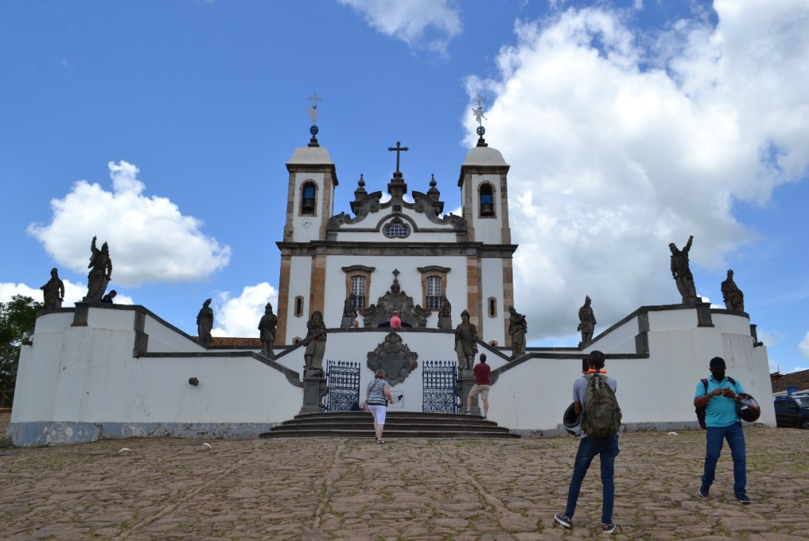
Figure 1: Sanctuary of Bom Jesus de Matosinhos, Congonhas do Campo, Minas Gerais: church and churchyard garnished by twelve prophets. Photograph by the author.

The path between the seven chapels, which starts at the base of the hill, crisscrosses the chapels and ends at the courtyard of the prophets. These statues guard the entrance to the sanctuary in a cross shape (typical of baroque architecture, evoking Christ’s sacrifice for humanity and its atonement through the mediation of Christ). The statues face the mountains of the Iron Quadrangle (Quadrilátero Ferrífero) and the gardens renovated by Brazilian landscape architect Roberto Burle Marx (1909-1994) in 1973. As a whole, the sanctuary is an important landscape, architectural, and sacred ensemble, an icon of Minas Gerais.

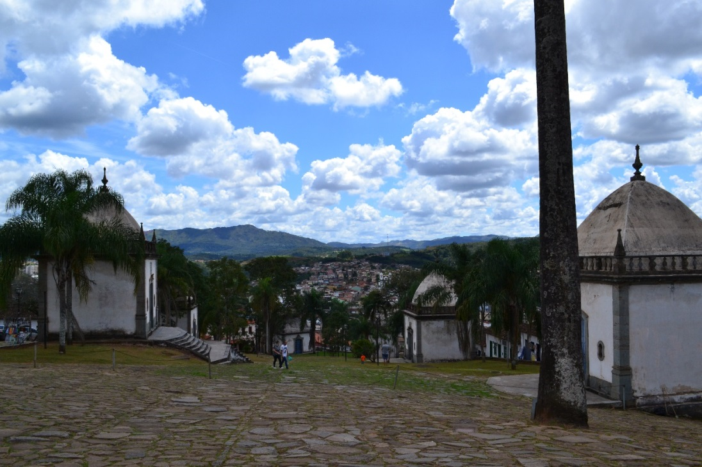
Figure 2: Sanctuary of Bom Jesus de Matosinhos, Congonhas do Campo, Minas Gerais: The seven chapels. Photograph by the author.

Germain Bazin described the relationships between the Passos do Calvário and other similar complexes in the tradition of European Catholicism, for example, the Santuario della Madonna di San Luca in Bologna, and the Calvaire du Mont Valérien near Paris. However, the Sanctuary of Bom Jesus de Congonhas’ greatest inspiration is the Santuário de Bom Jesus de Braga in Portugal.
For Robert Chester Smith, the inspiration for Aleijadinho’s prophets draws from oriental figures from the Old Testament, present in Portuguese tiles from the seventeenth and eighteenth centuries, which would have been known to the artist. Dialoguing with Chester’s investigations, Nancy Davenport also points to the influence of Northern Renaissance art, which was later transmitted to Portugal, as Aleijadinho’s main inspiration. According to Davenport, the left side of the Bladelin Altar Piece, representing August and the Sibyl Tiburtina, a work by the Flemish painter Rogier van der Weyden (died 1464), produced between 1452-1455, now at the Staatliche Museum in Berlin, inspired the representations of the Portuguese prophets.

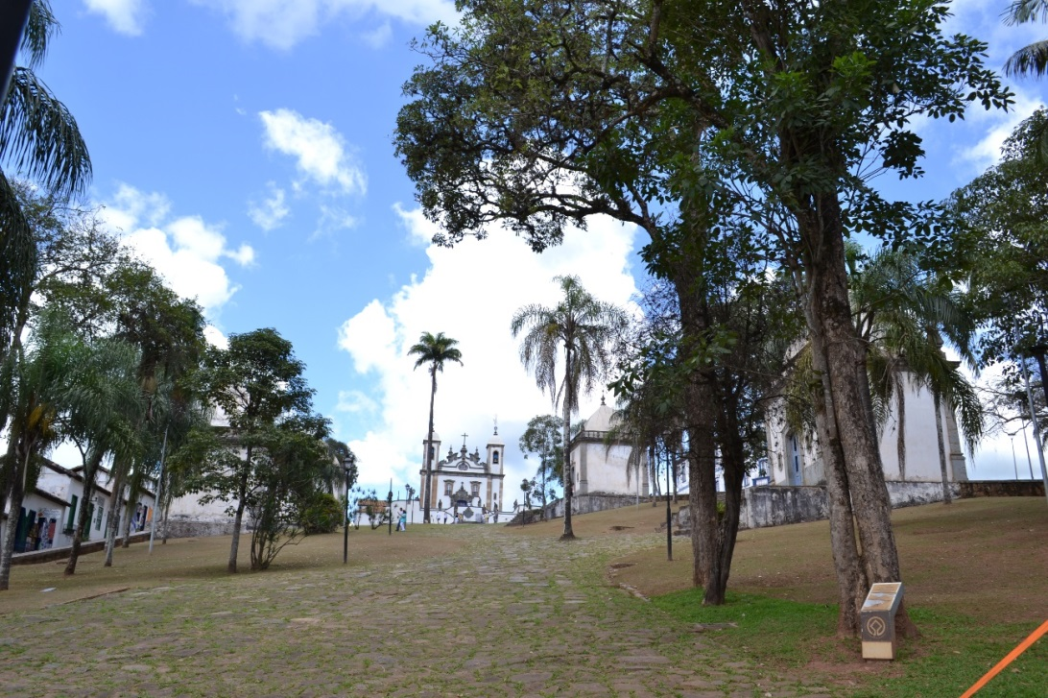
Figure 3: Sanctuary of Bom Jesus de Matosinhos, Congonhas do Campo, Minas Gerais: The seven chapels (detail) and the mountains of the Iron Quadrangle. Photograph by the author.

Following the chronology outlined by Myriam Ribeiro de Oliveira, the construction of the Santuário do Bom Jesus de Matosinhos was concluded in 1776. In 1777 followed the completion of the churchyard and the staircase. In 1794, the bishop of Mariana (Minas Gerais) allowed the building of the Capelas dos Passos. Between August 1st, 1796, and December 31th, 1799, Aleijadinho and his team carved 66 wooden images, distributed over the seven chapels. The statuary was colored by Manoel da Costa Ataíde. On the 31st of December, 1799, Aleijadinho was tasked with sculpting the prophets in the Basilica's churchyard, a task he completed on December 27, 1800.
Several reasons led us to choose the Santuário de Bom Jesus de Congonhas as a reference to reflect on historical-legal Iconology. Aleijadinho’s magnum opus was concluded at the height of his career but close to his death, when the symptoms of his illness were already advanced. It united the colonial architecture of the Capelas dos Passos, the church, and Baroque/Rococo paintings and sculptures. Aleijadinho's work in Congonhas do Campo invites us to walk along the Passos do Calvário, a true sacred outdoor theater, leading to the prophets' predictions. It allows the faithful, unable to go to the Holy Land, to undergo the mysticism of redemption and attain the imperfect system of human justice at their own pace. It is important to state that only a few years before Aleijadinho’s work began, Minas Gerais attempted to rebel against the Portuguese Crown in the most significant event of the century in Brazil. Leader of the rebels Tiradentes was hanged on April 21st, 1792. These elements were undoubtedly present in the artists’ minds at the time.
The analysis of the Steps (Passos do Calvário) by Myriam Ribeiro de Oliveira explains the mystical pathway, alongside the Calvário do Cristo, starting at the foot of the hill with the Capela da Ceia. Baroque’s theatrical drama is present in Christ’s betrayal, shocking and angering some apostles, as can be noted in the gestures of the sculptures. The indents of the carving give movement to the figures. The exception is Judas, who is sitting at the edge of the table with his head down and a sack of money in his hand, surprising the companion next to him.

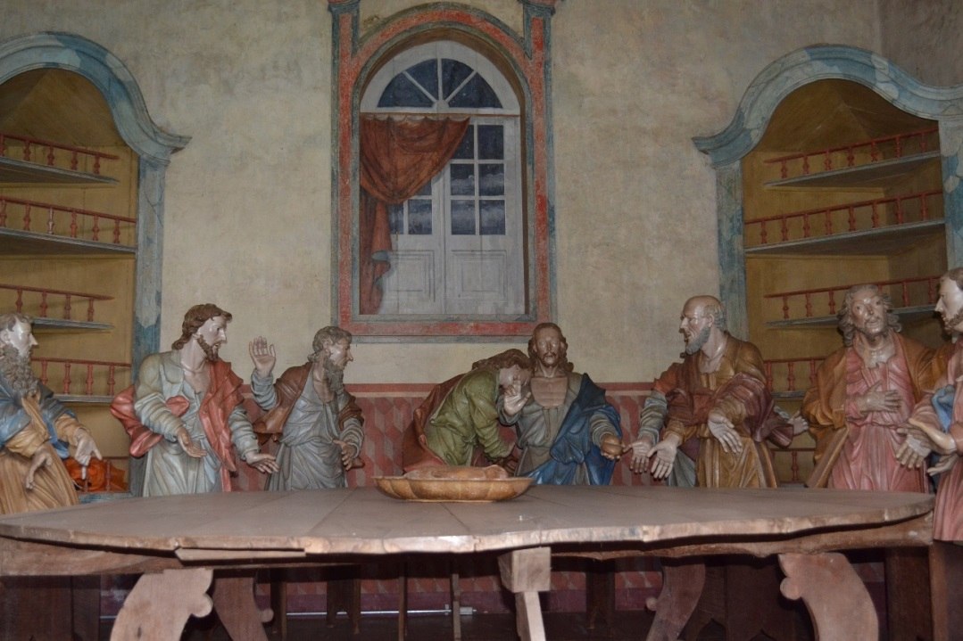
Figure 4: Sanctuary of Bom Jesus de Matosinhos, Congonhas do Campo, Minas Gerais: The Capela da Ceia (Holy Supper Chapel). Photograph by the author.

The servants’ clothing in the Holy Supper is curious, mediating the scene with the spectator, as they are not barefoot, like in traditional representations of the event. The servant on the right wears tight-fitting culottes and a waistcoat buttoned at the front, typical garments of eighteenth century Minas Gerais, unlike the long tunics and traditional cloaks of Gospel depictions.

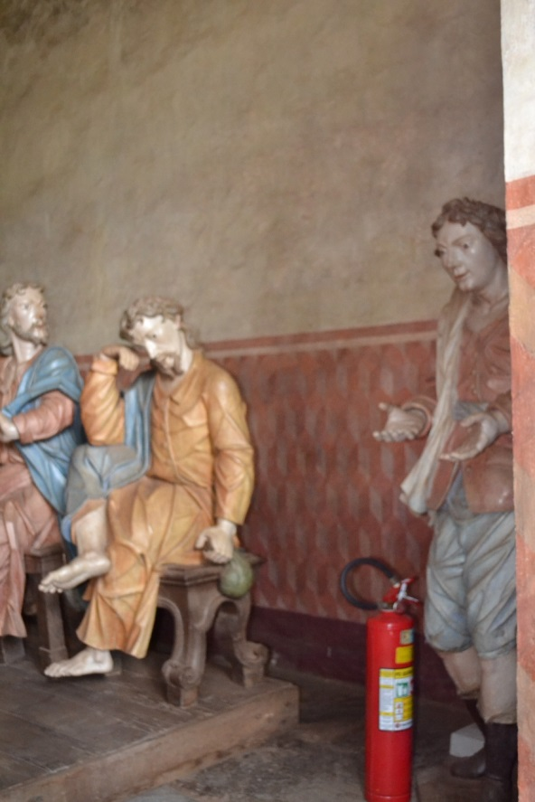
Figure 5: Sanctuary of Bom Jesus de Matosinhos, Congonhas do Campo, Minas Gerais: The Capela da Ceia (Holy Supper Chapel (detail: Judas). Photograph by the author.

Aleijadinho uses a similar resource in the third scene, the Arrest, where the roman guards’ uniforms are adapted to colonial fashion. Boots substitute sandals, and the tunics allow shorts to be seen underneath. Similarly, the roman soldiers’ boots in the Capela da Flagelação e da Coroação de Espinhos are like those used by the dragoons of the Portuguese Crown, based at Cachoeira do Campo, district of Vila Rica, where the governor of the Minas Gerais province, Viscount of Barbacena, lived. Also, a soldier is using a Phrygian hat, typical of a sans-culotte of the French Revolution..

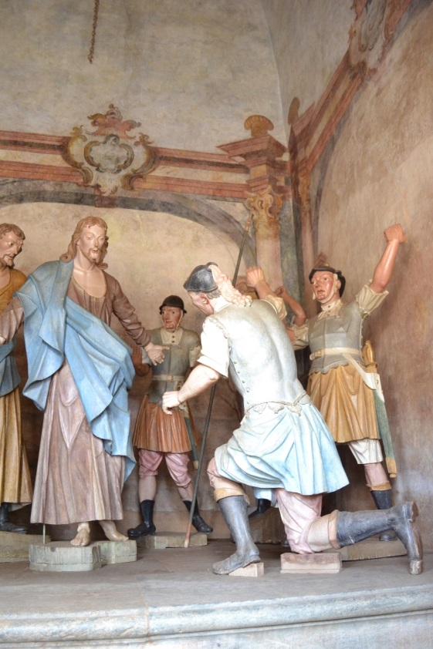
Figure 6: Sanctuary of Bom Jesus de Matosinhos, Congonhas do Campo, Minas Gerais: The Capela da Flagelação e da Coroação de Espinhos (detail: Roman soldiers). Photograph by the author.

Two aspects stand out in these scenes in the same chapel. First, following longstanding European iconographic tradition, Christ’s hands are bound and put on a support, similar to the pelourinho, a pillar that symbolizes colonial criminal law and justice. Every hamlet elevated to village status would receive a pelourinho, generally in front of the town hall and jail. These wood or stone pillars were used for repression and flogging, especially for enslaved people and lawbreakers. Moreover, the images of Christ in this chapel and the next obe, Cruz-às-Costas, show a thick line of red blood around His neck, which could also refer to the ropes used for hanging.

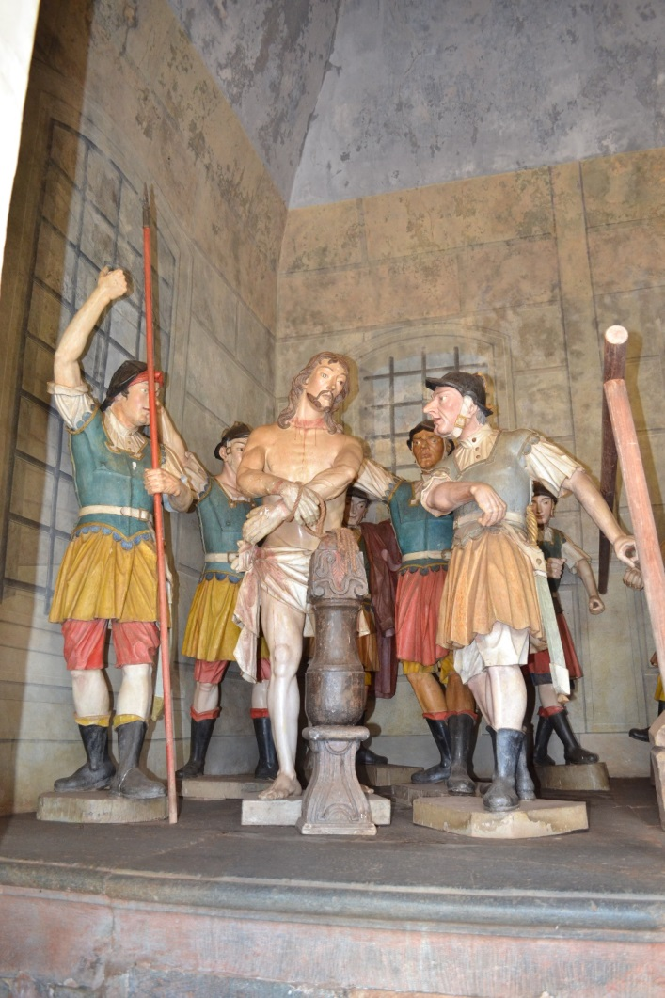
Figure 7: Sanctuary of Bom Jesus de Matosinhos, Congonhas do Campo, Minas Gerais: The Capela da Flagelação e da Coroação de Espinhos (detail: the pelourinho and a thick line of red blood around Christ’s neck). Photograph by the author.

All these elements can be seen as allusions to colonial justice. Conjecturally, a comparison can be drawn between the historical-political context of Christ, who announced a new sense of justice and was later killed, and Tiradentes, who was a central figure of Minas Gerais’ uprising against the Crown and was also condemned to dead and killed, for treason. Tiradentes (Joaquim José da Silva Xavier) was one of the leaders of the Inconfidência Mineira, a conspiracy against the Portuguese colonial regime. He was captured in 1790 and was executed by the Crown in 1792. The Inconfidência Mineira was a precursor of Brazilian independence. Inspired by the European Enlightenment and by the American Revolution, the Inconfidência Mineira denounced the abusive collection of taxes promoted by the Portuguese colonial system, and intended to establish a republic in Brazil. Tiradentes took the blame for the rebellion alone and sacrificed himself. As a common European tradition transmitted to Brazil, high treason’s punishment involved death, the salting of the criminal's house, and the erection of an infamy column to remind everyone of the subversion.

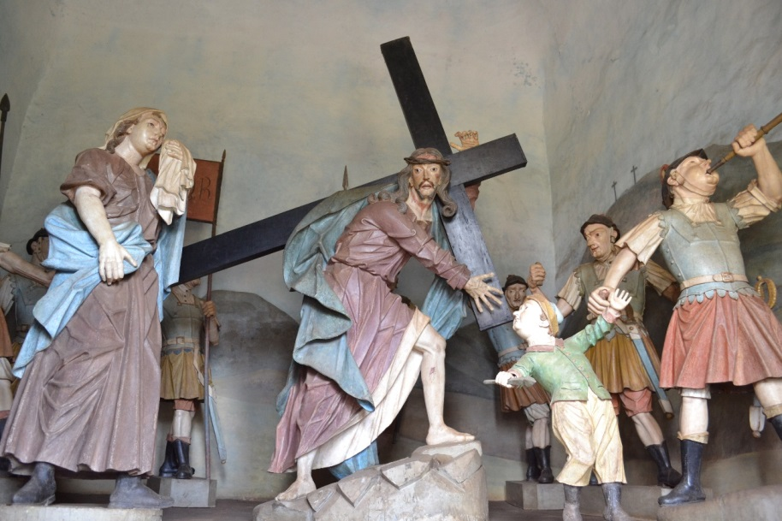
Figure 8: Sanctuary of Bom Jesus de Matosinhos, Congonhas do Campo, Minas Gerais: The Capela da Cruz-às-Costas (detail: a thick line of red blood around Christ’s neck). Photograph by the author.

In this case, the human law emitted by the tyrant is consciously disobeyed, respecting divine law, passively assuming the condemnation in respect of a superior divine structure. Carolin Behrmann points out:

The interpretation of martyrdom as resistance to the law and the orders of the tyrant, with reference to the divine law, leads to a central point of legal theory and the question of epikeia (Gr. indulgence), the principle that a law can be broken to achieve a greater good. According to one of the most important legal thinkers at the time, Francisco Suárez, who taught at the Roman Jesuit College around 1580, virtuous behavior is meant to turn on moral grounds and according to the legal standard. He discusses situations in which an imperative of the law is not appropriate, or even meaningful, and concludes that a person has the right to break the law if he decides to act ethically instead. One might refuse the legal order to fulfill the command of Divine Law, which would be the soul of Law itself.

This hypothesis is a by-product of iconographic and iconological analyses. It is projected conjecturally, identifying that Aleijadinho may have anticipated the comparison which would become common in the Brazilian Republic: the approximation of Tiradentes and Christ’s appearances. Long beards and hair are present in Pedro Américo’s (1843-1905) iconic painting Tiradentes supliciado from 1893.

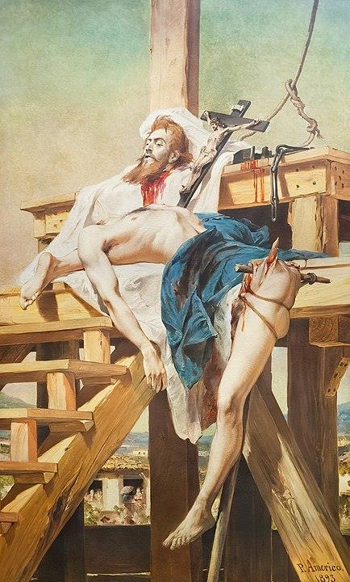
Figure 9: Pedro Américo Figueiredo e Melo, Tiradentes Supliciado, oil on canvas, 1893. Source: Fundação Museu Mariano Procópio, Juiz de Fora, Minas Gerais, Brazil.

The possible approximation between the images of Christ and Tiradentes also can be found in the paintings Martírio de Tiradentes (1893) by Francisco Aurélio de Figueiredo e Melo (1856-1916), and Tiradentes (1922) by Oscar Pereira da Silva (1867-1939). These works attempt to connect Tiradentes’ image to national unity, liberty, and the civic project of the new republic, implanted in Brazil in 1889. All these works were produced after that date.
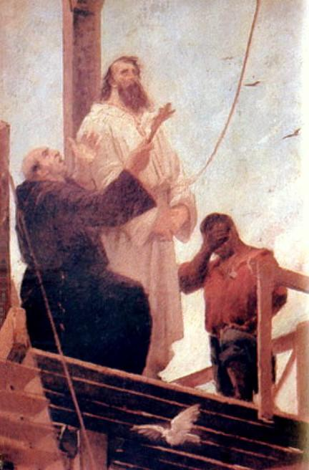
Figure 9: Aurélio de Figueiredo, Martírio de Tiradentes, oil on canvas, 1893. Source: Museu Histórico Nacional/Ibram, Rio de Janeiro.

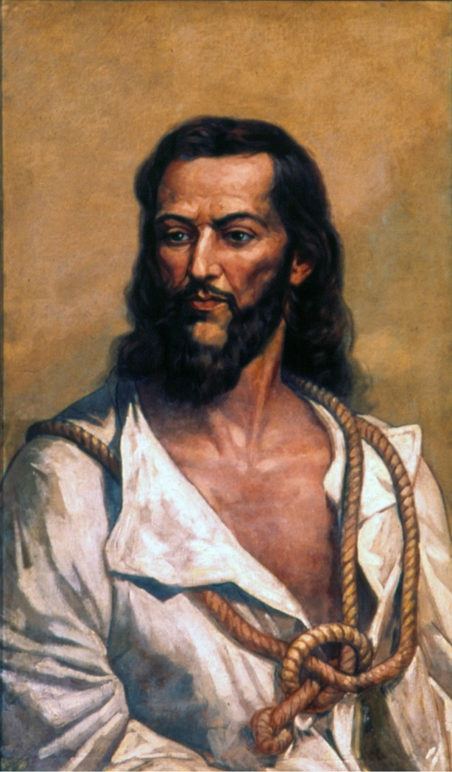
Figuur 10: Oscar Pereira da Silva, Tiradentes, oil on canvas, 1922. Source: Fundação Museu Paulista, Universidade de São Paulo, São Paulo.

Following this hypothesis, it could also be conjectured that, by associating Christ’s executioners to the soldiers of the Portuguese colonial guard, Aleijadinho would denounce, in his way, the fallibility of the colonial justice system, which suppresses and silences those who rebel and contribute to the destabilization of the prevailing legal order. With the Christ-Aleijadinho comparison in mind, considering the martyrdom undergone by both, the figure of Judas, present in the first chapel (of the Holy Supper), could evoke the traitors of the Minas Gerais uprising, like Joaquim Silvério dos Reis. In exchange for money, he told the colony’s governor about the conspiracy, much to the surprise of his companions, just like the apostle next to Judas in Aleijadinho’s scene. In some sense, the bag of coins is the element that allegorically unites the two historical events.
These allegations would become even more colorful with the inversion of the traditional schematism of Holy Scripture, taking into account that in the Santuário do Bom Jesus de Matosinhos, the Capelas dos Passos and the New Testament are located before the prophets of the Old Testament. Germain Bazin says this inversion goes back to the patristic tradition of the Old Testament being read in agreement with the New, whose apogee centers on the figure of Christ. The Morro do Alto Maranhão echoes the sacred mountains that mark the unity between Heaven and Earth: ‘in the Old Testament, the voice of the Eternal is heard in lighting and thunder; in the New, it is the death of Christ, source of man’s salvation, in the same place he was made’.

4. CONCLUSION: THE PROPHETS AND THE SECRET DENUNCIATION OF PORTUGUESE INJUSTICE

Concerning the relation between the Prophets and Mineiro artistic forms, Carlos Drummond de Andrade poetizes a fantastic meeting, a confabulation, present in the dialogue of the statues, which, according to the poet, would refer to a form of organized madness, explosive and contagious, that would mark the liberal revolutions of Minas Gerais.
Mauro Werkema also imagines a certain conspiratorial appearance of the prophets, who proclaim the biblical awareness that the unjust will be punished by a social order based on justice and equality. In Werkema's hypothesis, the inversion of the biblical reading, present in Congonhas, would allegorically evoke the negotiations and projects of the rebels. At the same time, it would update the prediction of the Count of Assumar in 1719, after the Sedition of Filipe dos Santos, an uprising against the Portuguese Crown in the first decades of the eighteenth century, who stated that ‘the days of Minas Gerais never dawn serene and that its climate would be the tomb of peace and the cradle of rebellion’. Following this line of thought and analyzing the sanctuary, it is connected to justice in the colonial period, and its prediction still remains on the lips of the prophets. Even though the Minas Gerais Conspiracy was not successful, the guard established by the prophets remains in the form of ‘the river’s third bank’, an expression dear to the Mineiro people. Vigilant, they predict that earthly justice is ungodly and that freedom and justice will one day be realized transcendentally, as noted in Augustinian eschatology (the primary characterization of justice in Baroque) and now, physically, among men. Minas Gerais saw the hanging of Tiradentes, immolated like Christ, suffering the martyrdom that sets everyone free, but would keep alive and open the haughty reflection of the prophets, who watch over while waiting for justice among earthly institutions. In this way, when one walks the path of the sanctuary, justice is lived, with a certain refusal of the traditional movement from catabasis to anabasis.
The sculptures in the chapels, their polychromies, the frescoes on their walls and ceilings, their doorways, the Latin transcriptions of Gospel passages that are carved in the chapels’ façades, the gesture, the clothing, the inscriptions on the Prophets’ scrolls in the sanctuary’s churchyard: all these works contain elements and traits that would require calm and careful investigation, in the form of a historical iconology.

5. REFERENCES

Andrade, Carlos Drummond de, “Colóquio das Estátuas”, in: Carlos Drummond de Andrade, Passeios na Ilha. Divagações sobre a vida literária e outras matérias, São Paulo, 2011, 57-59.

Bazin, Germain, O Aleijadinho e a escultura barroca no Brasil, (transl. Mariza Murray), Rio de Janeiro, 1963.

Behrmann, Caroline, “On Actio: The Silence of Law and the Eloquence of Images”, Zeitschrift für Kunstgeschichte, 76.1, 2013, 51-70 (http://www.jstor.org/stable/43598697).

Bohrer, Alex, “Os Missais de Plantin e Outras Reminiscências Flamengas no Barroco Mineiro”, in: Werner Thomas, Eddy Stols, Iris Kantor & Júnia Furtado (eds.), Um Mundo Sobre Papel. Livros, Gravuras e Impressos Flamengos nos Impérios Português e Espanhol (Séculos XVI-XVIII), São Paulo, 2014, 475-493.

Campos, Adalgisa Arantes, Introdução ao Barroco Mineiro. Cultura barroca e manifestação do Rococó em Minas Gerais, Belo Horizonte, 2006.

Carvalho, José Murilo de, A Formação das Almas: o Imaginário da República no Brasil, São Paulo, 1990.

Casanova, Marco, Eternidade Frágil. Ensaios de temporalidade na arte, Rio de Janeiro, 2013.

Davenport, Nancy, “Fontes Europeias para os Profetas de Congonhas do Campo” (transl. Sérgio Coelho et al.), in: Affonso Ávilla (ed.), Barroco: Teoria Análise, São Paulo, 1997, 407-421.

Decock, Wim, Theologians and Contract Law: The Moral Transformation of the "Ius Commune" (ca. 1500-1650), Leiden, 2012.

De Win, Paul, “Works of art as a form of criminal punishment in the Low Countries (14th–17th c.)”, in: Stefan Huygebaert et al. (eds.), The Art of Law. Artistic Representations and Iconography of Law and Justice in Context, from the Middle Ages to the First World War, Cham, 2018, 299-314.

Duarte, Luís Miguel, Justiça e Criminalidade no Portugal Medievo (1459-1481), Lisboa, 1999.

Faoro, Raymundo, Os Donos do Poder. Formação do Patronato Político Brasileiro, São Paulo, 2012.

Figueiredo, Lucas, O Tiradentes. Uma biografia de Joaquim José da Silva Xavier, São Paulo, 2018.

Foucault, Michel, Vigiar e Punir (transl. Raquel Ramalhete), Petrópolis, 1999.

Furtado, Júnia Ferreira & Kantor, Iris, “Introdução à Edição Brasileira”, in: Werner Thomas, Eddy Stols, Iris Kantor & Júnia Furtado (eds.), Um Mundo Sobre Papel. Livros, Gravuras e Impressos Flamengos nos Impérios Português e Espanhol (Séculos XVI-XVIII), São Paulo, 2014, 9-13.

Guimarães Rosa, João, “A terceira margem do rio”, in: João Guimarães Rosa, Primeiras Estórias, Rio de Janeiro, 2001, 79-85.

Hespanha, António Manuel, Cultura Jurídica Europeia. Síntese de um Milênio, Florianópolis, 2005.

Le Goff, Jacques, Raízes Medievais da Europa (transl. Jaime A. Clasen), Petrópolis, 2007.

Martyn, Georges, “Law, Justice and Art in Historical Perspective”, in: Stefan Huygebaert et al. (eds.), The Art of Law. Artistic Representations and Iconography of Law and Justice in Context, from the Middle Ages to the First World War, Cham, 2018, 3-24.

Martyn, Georges, “Introdução à iconologia histórica do direito”, in: Arno Dal Ri Jr., Caetano Dias Corrêa & Diego Nunes (eds.), Anais dos XVI Encontros de História do Direito da UFSC – Printing & Iconology as Legal-Historical Sources, Florianópolis, 2020, 12-37.

Maxwell, Kenneth, A Devassa da Devassa. A Inconfidência Mineira – Brasil e Portugal (1750-1808) (transl. João Maia), São Paulo, 2010.

Mello e Souza, Laura de, “Tensões sociais em Minas na segunda metade do século XVIII”, in: Adauto Novaes (ed.), Tempo e História, São Paulo, 1992, 347-366.

Oliveira, Myriam Andrade Ribeiro de, Aleijadinho: Passos e Profetas, Belo Horizonte, 2002.

Oliveira, Myriam Andrade Ribeiro de, Os Passos de Congonhas e suas Restaurações, Brasília, 2011, http://portal.iphan.gov.br/, accessed 20 October 2022.

Panofsky, Erwin, Significado nas Artes Visuais (transl. Maria Clara F. Knesse & J. Guinsburg), São Paulo, 2019.

Rosa, António Amaro, O Pelourinho Português, Coimbra, 2015.

Santiago, Camila Fernanda Guimarães, “Circulação e usos em Minas Gerais de gravuras religiosas da Oficina Plantiniana”, in: Werner Thomas, Eddy Stols, Iris Kantor & Júnia Furtado (eds.), Um Mundo Sobre Papel. Livros, Gravuras e Impressos Flamengos nos Impérios Português e Espanhol (Séculos XVI-XVIII), São Paulo, 2014, 495-511.

Smith, Robert Chester, Congonhas do Campo, Rio de Janeiro, 1973.

Werkema, Mauro, História, Arte e Sonho na Formação de Minas, Belo Horizonte, 2010.

Professor of Philosophy of Law and History of Law at the Federal University of Viçosa, Minas Gerais, Brazil, since 2014, dedicating his research to the relationship between phenomenology and hermeneutics, especially to the thought of Hans-Georg Gadamer; he obtained his PhD degree in Law at the Federal University of Minas Gerais, Belo Horizonte, Brazil, in 2017.
Panofsky 2019, 29-30.
Panofsky 2019, 50.
Panofsky 2019, 63.
Martyn 2020, 14-15.
Martyn 2018, 8.
Martyn 2020, 18.
Martyn 2020, 22-26.
De Win 2018; see also Martyn 2020, 19.
Hespanha 2005, 58.
Decock 2012, 48.
Hespanha 2005, 69.
Mello e Souza 1992, 350.
Campos 2006, 29.
Campos 2006, 7.
Campos 2006, 9-11.
Campos 2006, 14.
Le Goff 2007, 161.
Maxwell 2010, 147-148.
Furtado & Kantor 2014, 9.
Furtado & Kantor 2014, 10.
Furtado & Kantor 2014, 10.
Santiago 2014, 500.
Santiago 2014, 504-505.
Bohrer 2014, 482.
Bohrer 2014, 483.
Bohrer 2014, 484-485.
Bohrer 2014, 486.
Santiago 2014, 505.
Bohrer 2014, 487-488.
Bohrer 2014, 489.
Bazin 1963, 87.
Bazin 1963, 214.
The website of the Congonhas Museum presents information, images, and collections about the architectural complex of the city: https://www.museudecongonhas.com.br/. The website of the Instituto do Patrimônio Histórico e Artístico Nacional, IPHAN, a public autarchy of the Brazilian government, is also a source of information about Brazilian architectural ensembles: http://portal.iphan.gov.br/. IPHAN, under the management and organization of art historian Myriam Andrade Ribeiro de Oliveira, renowned in the study of Brazilian baroque art, has prepared a rich inventory regarding the Congonhas Steps and its restorations, see Oliveira 2011.
Bazin 1963, 220.
Bazin 1963, 238.
Smith 1973, 25.
Davenport 1997, 409.
Oliveira 2002, 23-29.
Casanova 2013, 368.
Oliveira 2002, 32.
Oliveira 2002, 32.
Oliveira 2002, 36.
Bazin 1963, 376.
Duarte 1999, 434; Faoro 2012, 217; Foucault 1999, 43; Rosa 2015, 45.
Campos 2002, 25.
De Win 2018, 309.
Behrmann 2013, 67.
Figueiredo 2018, 288-289, images 58 and 59.
Carvalho 1990, 65.
Joaquim Silvério dos Reis, a portuguese military in debt to his country, who lived in Minas Gerais in the eighteenth century, initially sympathized with the Inconfidência Mineira. Realizing that the conspiracy could fail, he denounced the collusion to the Crown, obtaining the forgiveness of his debts.
Bazin 1963, 255.
Andrade 2011, 58-59.
Werkema 2010, 48.
Mello e Souza 1992, 349.
Guimarães Rosa 2001, 79-85.

